Enviro Organizer

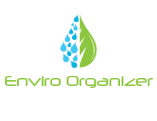

There are a lot of planners in the market which let users specify a certain task and the app would tell the person if it is overdue. For example, setting out a time of the day to do a certain task. However, there is not one that lets a user do a task and then capture things about a task. This app is aimed at students who primarily go on trips. During these trips, it is very common for the students to take photos while they’re at the place of interest. However, a lot of students forget which photos align to the correct trip due to the sheer number of trip’s they may have in a semester.

After a trip students, would discuss at what point a certain object such a rock for geology was found, what the app would do is take photos and give the user the option to select if they want to record gps location at the same time. This would align with the photo and would take a snapshot of the current gps location. This gives the user the whole project at their fingertips without having to worry about where certain pictures where taken. They would be able to take notes after taking the picture to add a sort of caption with the picture, as well as notes for the whole project.

The app is mostly aimed at Geology, Environmental and geography students. They are the most common students who go on trips that would involve organization such as this. The app is mostly centralized at students and hoping to evolve to help actual graduates of these degrees later in life.

Most app like this are more text/note based. You can set your tasks but usually a predefined photo is uploaded or used supplied by the actual app its self, and you cannot take photos within the actual project only add notes to it. There is also no features for GPS snapshots or even taking GPS in general which I would like my app to implement.

The app will only be targeted at android only currently then expanding onto iPhones.

**Examples of other Apps**

The only app I can find which has similar detail is the manageit app. Within the app you can have multiple projects and set dates within those projects milestones can be achieved. The manage it app has not got a place to store documents and pictures such as my app but makes use of the tools drop box provides to be able to upload documents that are related to a certain project.

Manageit project view with people on one project pictured below.

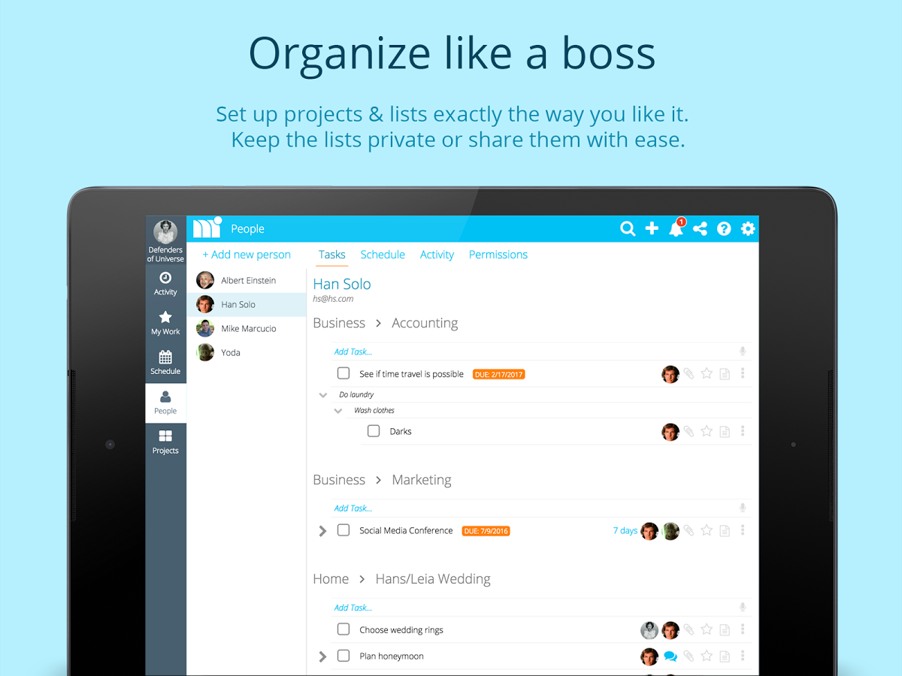

Other than the pictures and snapshots of current locations, the app has similarities to what I have in mind, it has Project overview too which is a feature I would like to implement, but not with tasks, instead with all the information needed to complete the tasks for students.

Other apps tend to be planner which is not what I aiming at, my app will help organize their work, but not remind people when to do a piece of work.

Overall, I Believe there is a place in the market for this app as people never really care or know what students like environmental, geologists and geography student may do when they do practical work. I have spoken to many students of these subjects and they believe that this would help them organize their work and get assignments done a lot quicker due to the help of GPS and pictures which map the picture taken to the current location, along with project names to help structure each project.